**Aim -**

To study and implement Security as a Service on AWS/Azure.

**Theory -**

A business model called SECaaS, or Security as a Service, offers security to IT companies on a subscription basis. A superior security platform is provided by the outsourced approach, which lowers the total cost of ownership than the business could supply on its own. With the use of cloud computing, security for the company is maintained by an outside party. For the necessary computational and storage resources to run their websites and apps, many enterprises rely on security services. SECaaS is impressed by the “Security as a Service (SaaS)” model as applied to implement security kind services and doesn’t need on-premises hardware, avoiding substantial capital

outlays. These security services typically embody authentication, antivirus, anti-

malware/spyware, intrusion detection, penetration testing, and security event management, among others.

The former method of doing things involved paying direct pricing for hardware as well as

ongoing fees for licenses to allow for the usage of that security code, which made it much more expensive. Instead, security as a service makes it simple and rational to use similar technologies.

Security can be availed by the following alliances:

* Encryption: makes the data unreadable until it has been authentically decoded, or encrypted.
* Network security: Network access management protocols are used to secure and keep an eye on network services.
* Email security: Protects against email frauds, spam, phishing, malware etc.
* Identification: Users can access with a valid login ID and legal permission, else forbids if it is not authenticated.
* Data loss prevention: Tools are built to monitor and secure data to protect from data loss.

**Procedure-**

Login to your AWS Management Console.

Create a new AWS EC2 instance with Ubuntu OS.

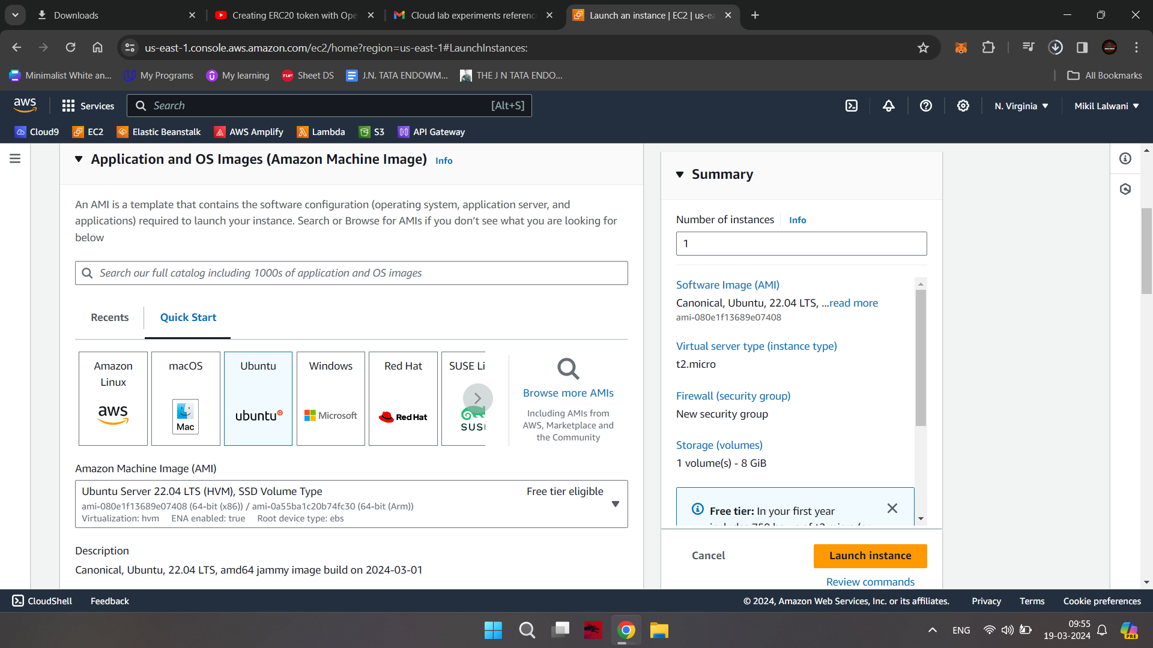

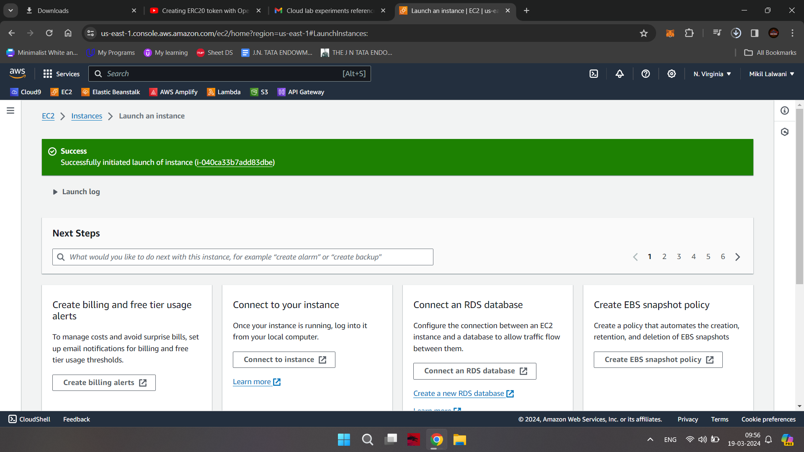

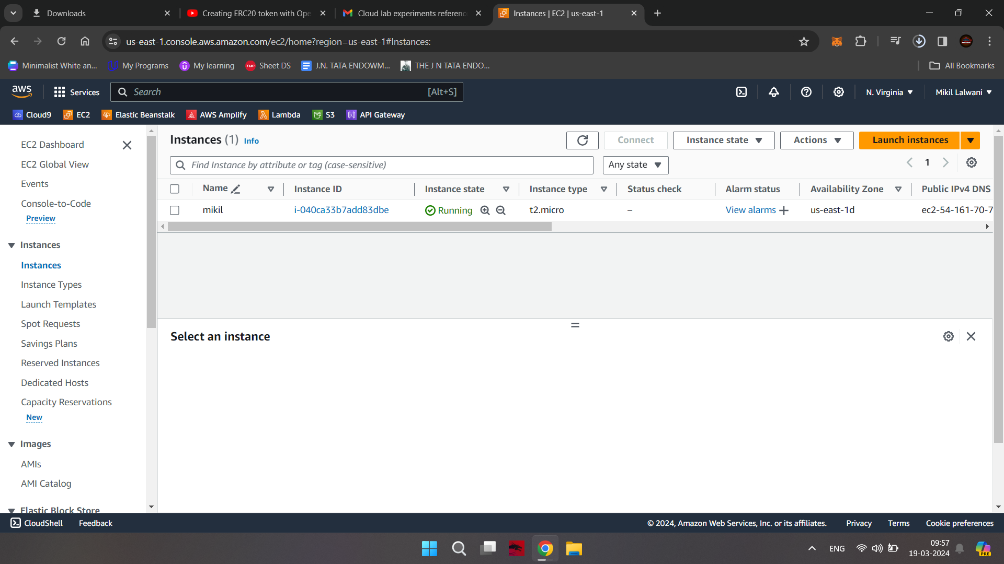

Connect with the EC2 instance using the AWS built in console.

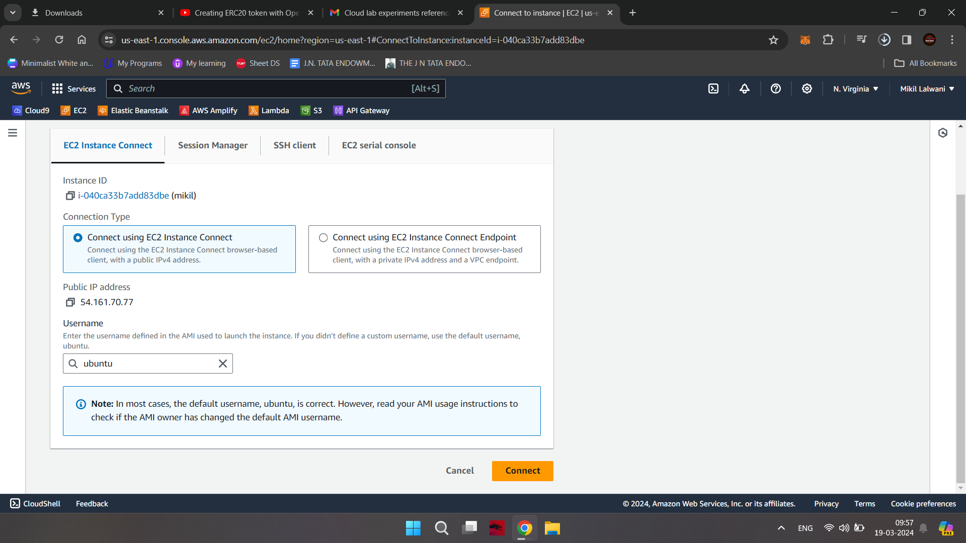

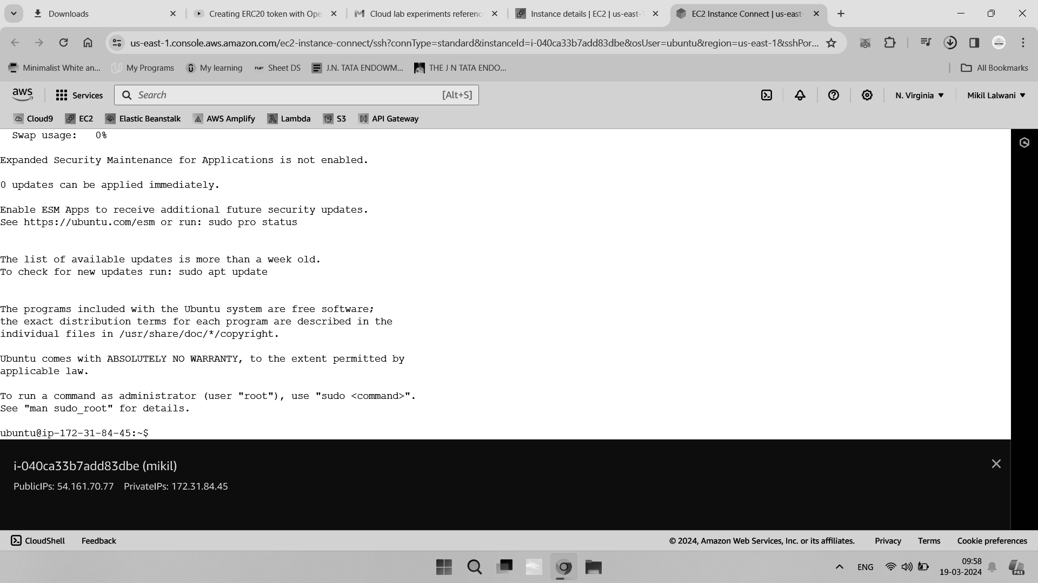

General Hardening

In this first step, you will implement some initial hardening configurations to improve the

overall security of your SSH server.

The exact hardening configuration that is most suitable for your own server depends heavily on your own threat model and risk threshold. However, the configuration you’ll use in this step is a general secure configuration that will suit the majority of servers.

You will edit the main OpenSSH configuration file in /etc/ssh/sshd_config to set the majority of the hardening options in this tutorial. Before continuing it is a good idea to create a backup of your existing configuration file so that you can restore it in the unlikely event that something goes wrong.

Create a backup of the file using the following cp command:

sudo cp /etc/ssh/sshd_config /etc/ssh/sshd_config.bak

This will save a backup copy of the file to /etc/ssh/sshd_config.bak.

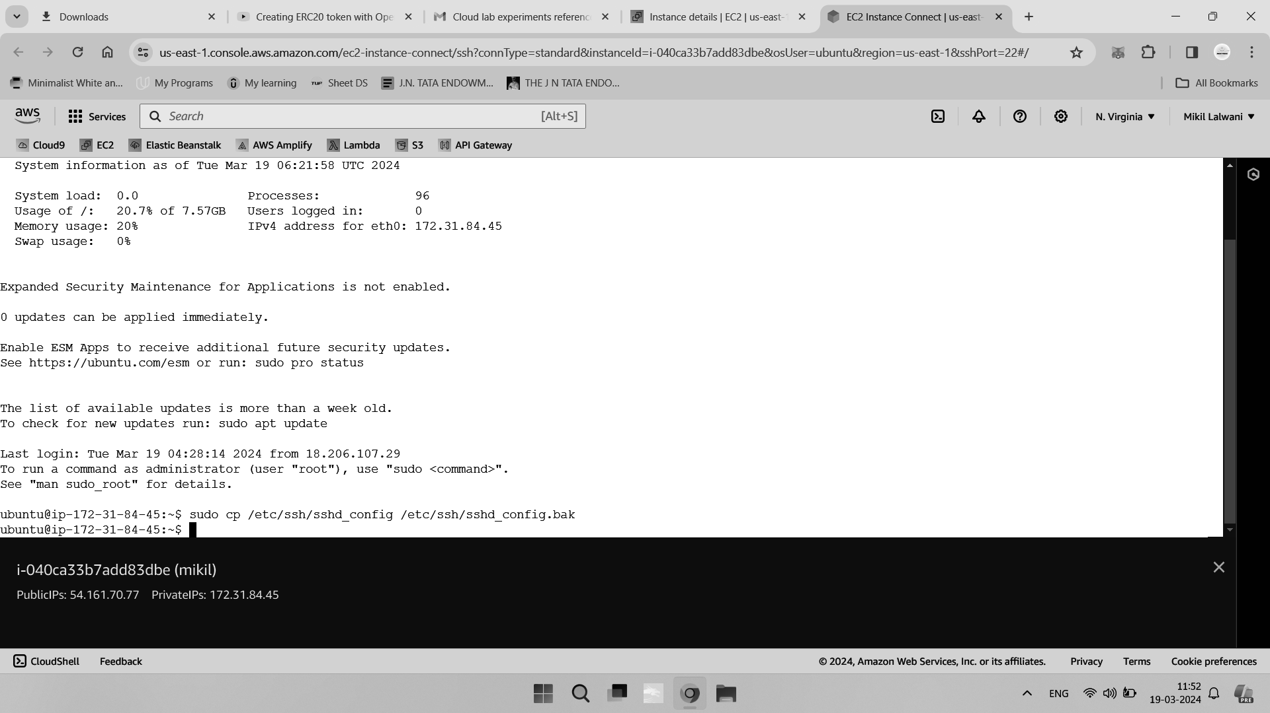

Next, review the current default OpenSSH configuration options that correspond to the

settings in /etc/ssh/sshd_config. To do this, run the following command:

sudo sshd -T

This will run OpenSSH server in extended test mode, which will validate the full configuration file and print out the effective configuration values.

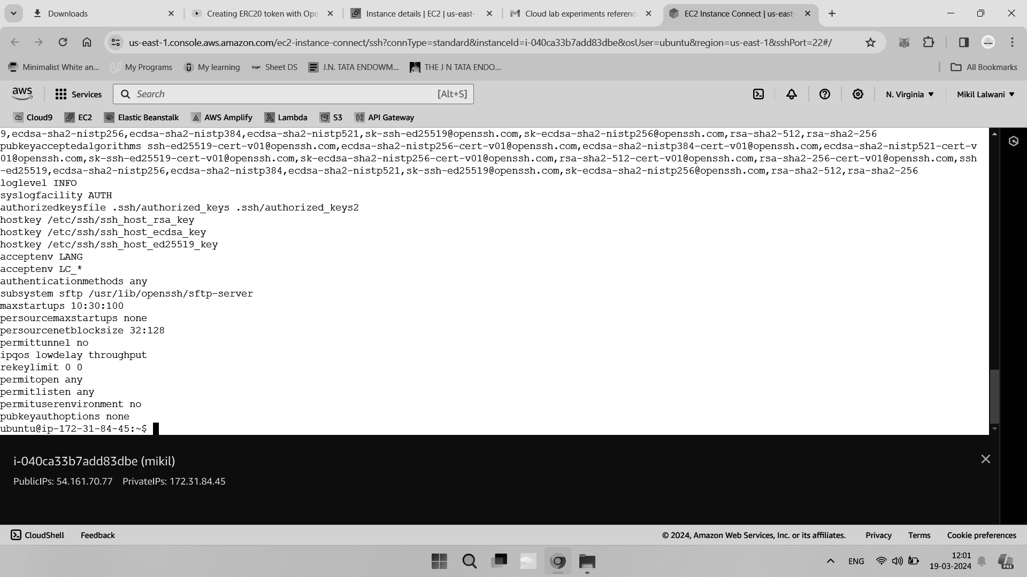

You can now open the configuration file using nano or your favorite text editor to begin

implementing the initial hardening measures:

sudo nano /etc/ssh/sshd_config

The first hardening option is to disable logging in via SSH as the root user. Set the

PermitRootLogin option to no by uncommenting or editing the line in sshd_config:

PermitRootLogin no

This option will prevent a potential attacker from logging into your server directly as root. It also encourages good operational security practices on your part, such as operating as a non-privileged user and using sudo to escalate privileges only when absolutely needed.

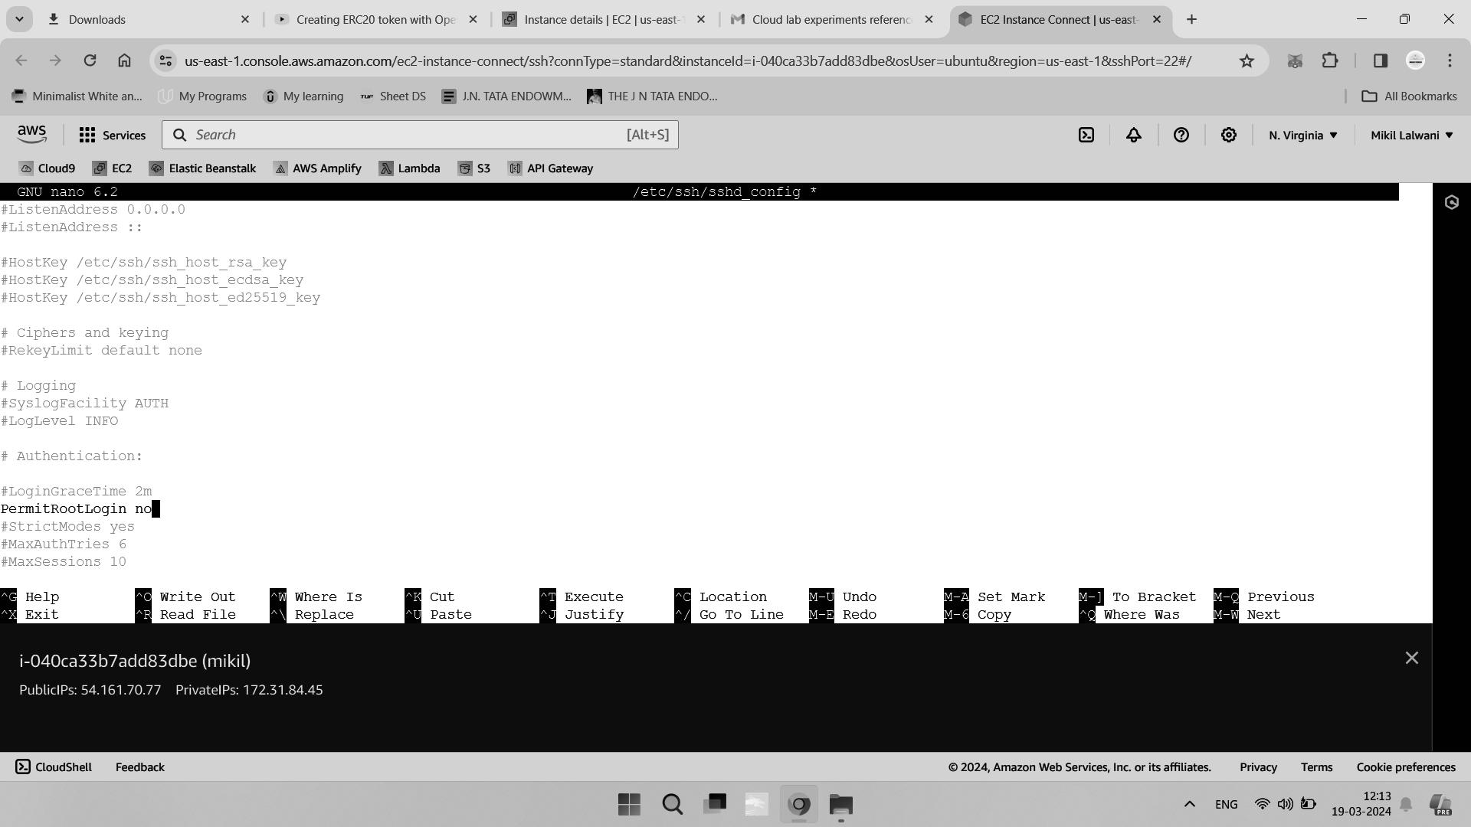

Next, you can limit the maximum number of authentication attempts for a particular login

session by configuring the MaxAuthTries option in sshd_config

MaxAuthTries 3

A standard value of 3 is acceptable for most setups, but you may wish to set this higher or lower depending on your own risk threshold.

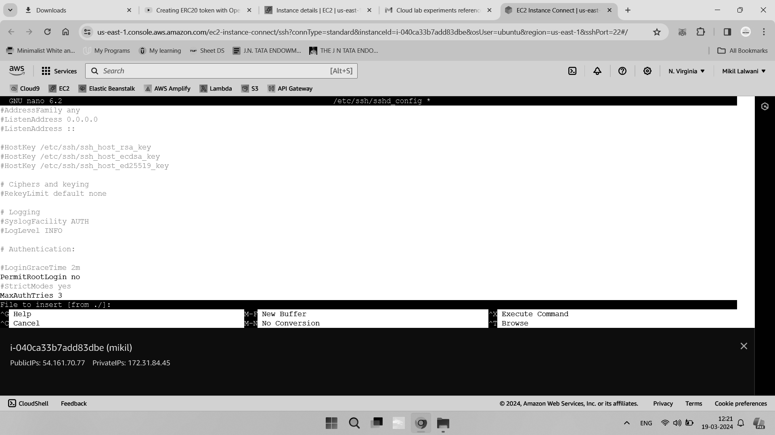

If required, you can also set a reduced login grace period, which is the amount of time a user has to complete authentication after initially connecting to your SSH server in sshd_config

LoginGraceTime 20m

The configuration file specifies this value in seconds.

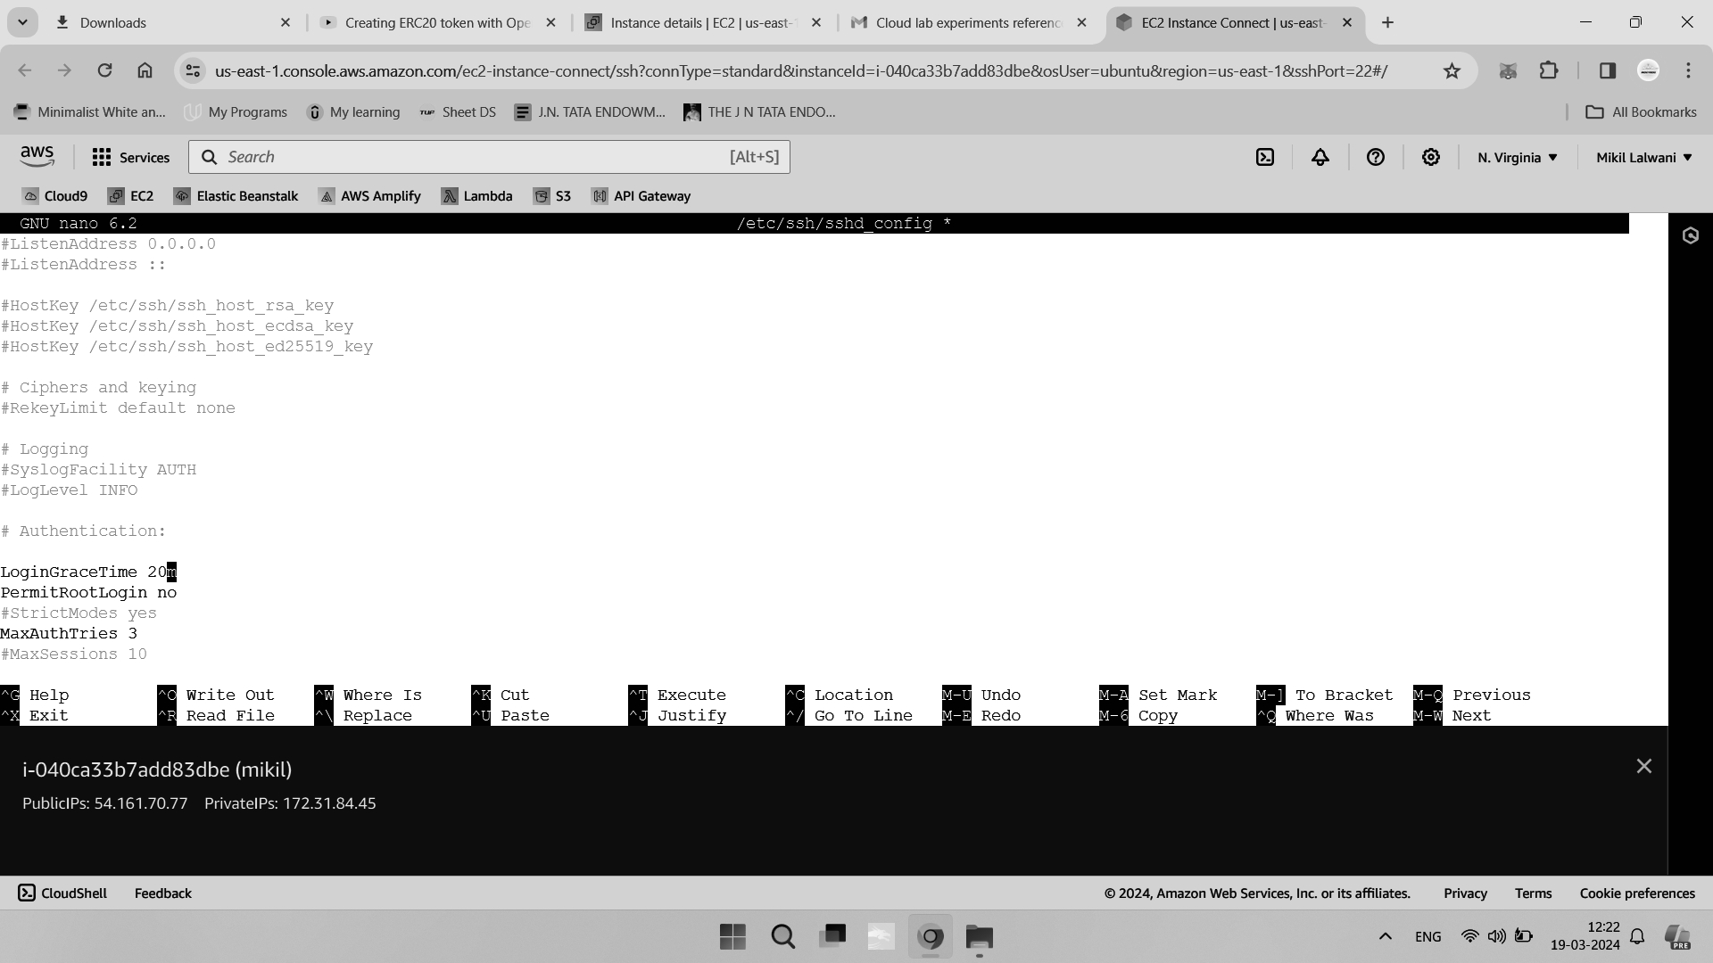

Setting this to a lower value helps to prevent certain denial-of-service attacks where multiple authentication sessions are kept open for a prolonged period of time.

If you have configured SSH keys for authentication, rather than using passwords, disable SSH password authentication to prevent leaked user passwords from allowing an attacker to log in sshd_config

PasswordAuthentication no

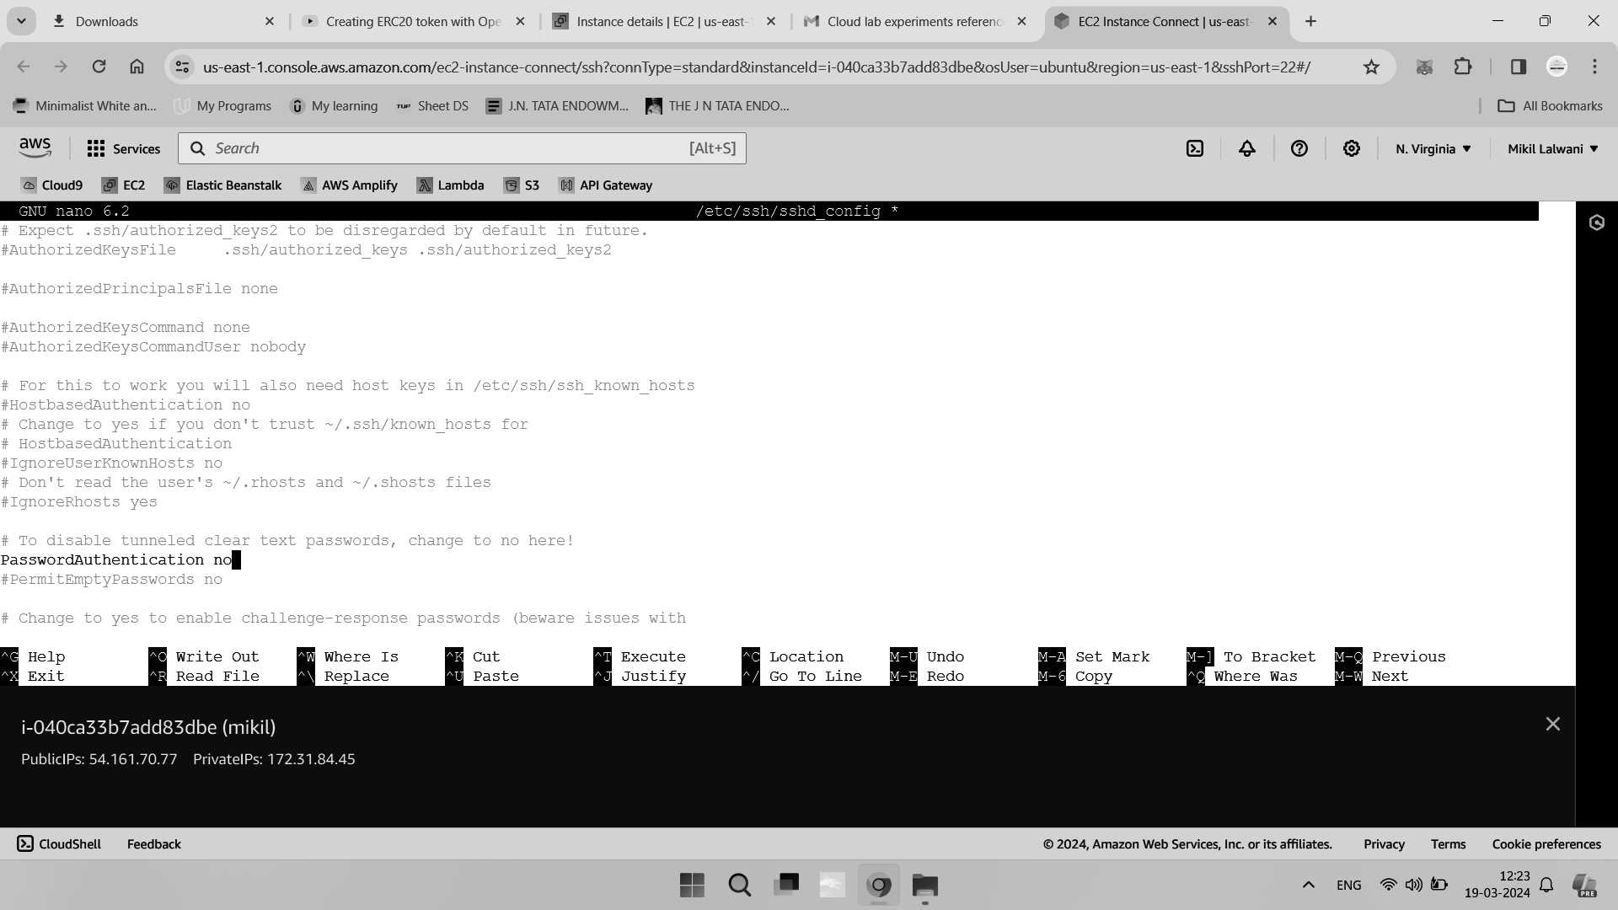

As a further hardening measure related to passwords, you may also wish to disable

authentication with empty passwords. This will prevent logins if a user’s password is set to a blank or empty value in sshd_config

PermitEmptyPasswords no

In the majority of use cases, SSH will be configured with public key authentication as the only in-use authentication method. However, OpenSSH server also supports many other authentication methods, some of which are enabled by default. If these are not required, you can disable them to further reduce the attack surface of your SSH server in sshd_config

ChallengeResponseAuthentication no

KerberosAuthentication no

GSSAPIAuthentication no

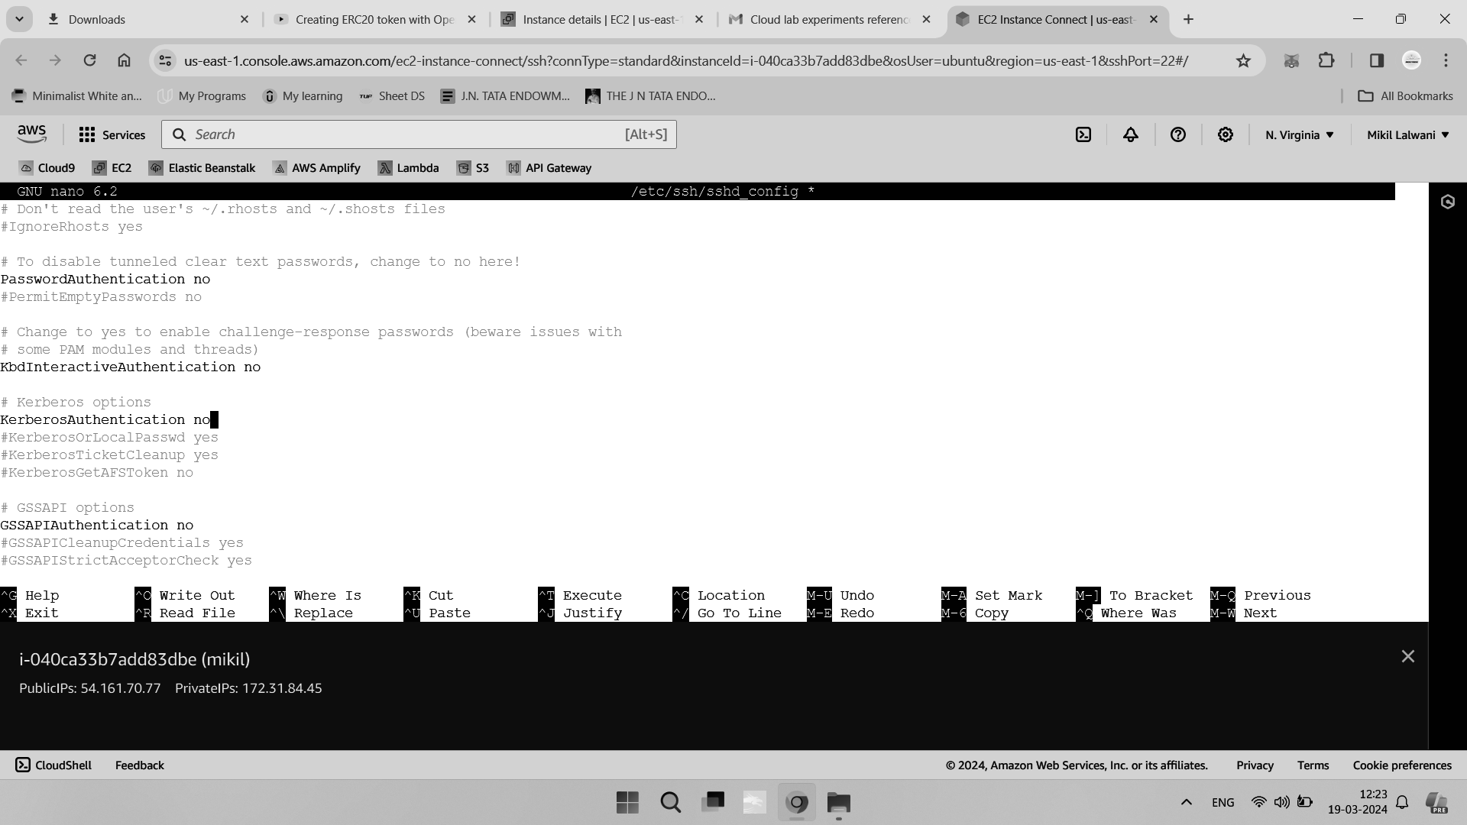

X11 forwarding allows for the display of remote graphical applications over an SSH

connection, but this is rarely used in practice. Disable it if you are not running a graphical environment on your server in sshd_config

X11Forwarding no

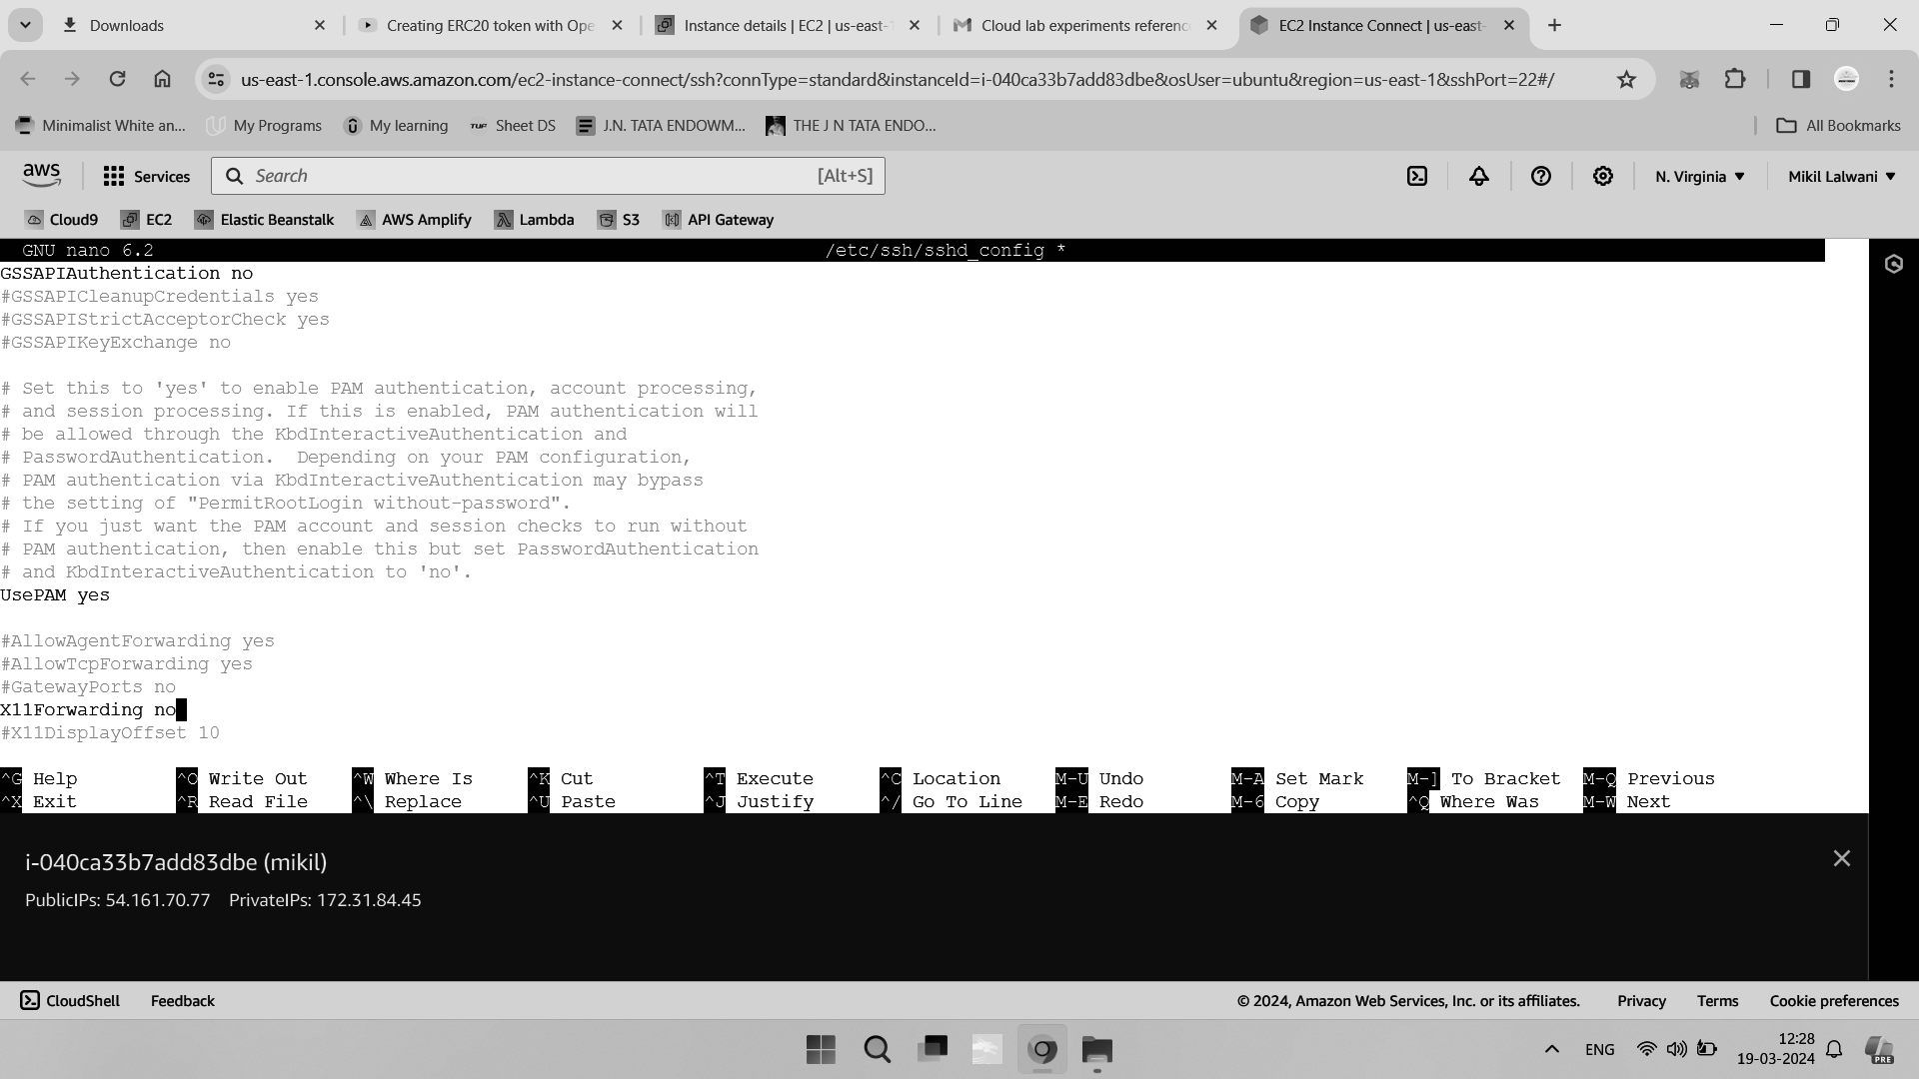

OpenSSH server allows connecting clients to pass custom environment variables. For

for example, a client can attempt to set its own $PATH or to configure terminal settings.

However, like X11 forwarding, these are not commonly used, so you can disable the option in most cases in sshd_config

PermitUserEnvironment no

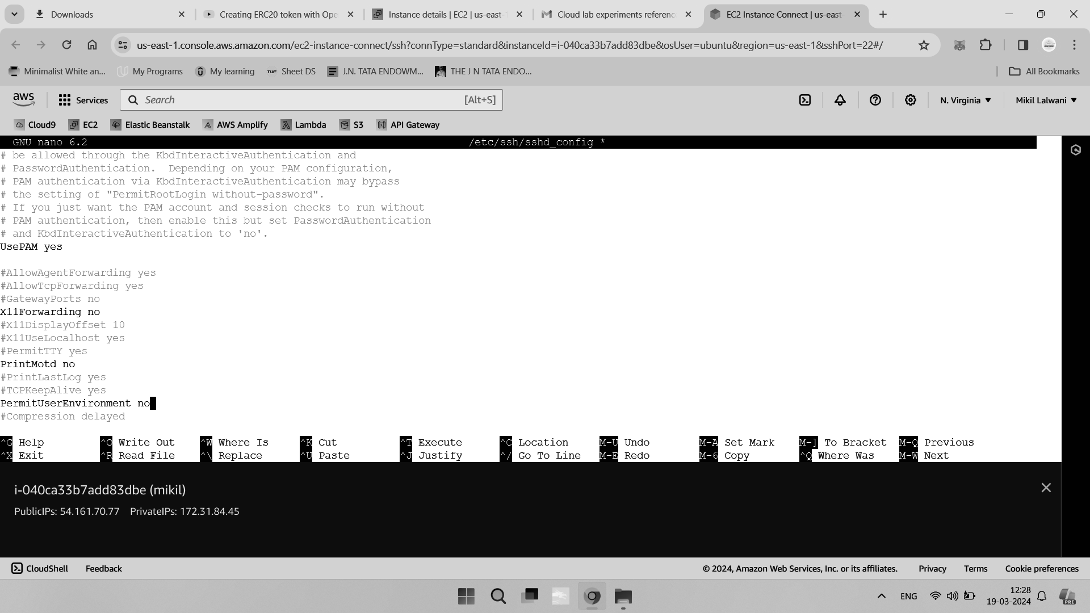

Implementing an IP Address Allowlist

You can use IP address allow lists to limit the users who are authorized to log in to your

server on a per-IP address basis. In this step, you will configure an IP allowlist for your

OpenSSH server.

In many cases, you will only be logging on to your server from a small number of known, trusted IP addresses. For example, your home internet connection, a corporate VPN appliance, or a static jump box or bastion host in a data center.

By implementing an IP address allowlist, you can ensure that people will only be able to log in from one of the pre-approved IP addresses, greatly reducing the risk of a breach in the event that your private keys and/or passwords are leaked.

You can identify the IP address that you’re currently connecting to your server with by using the w command:

W

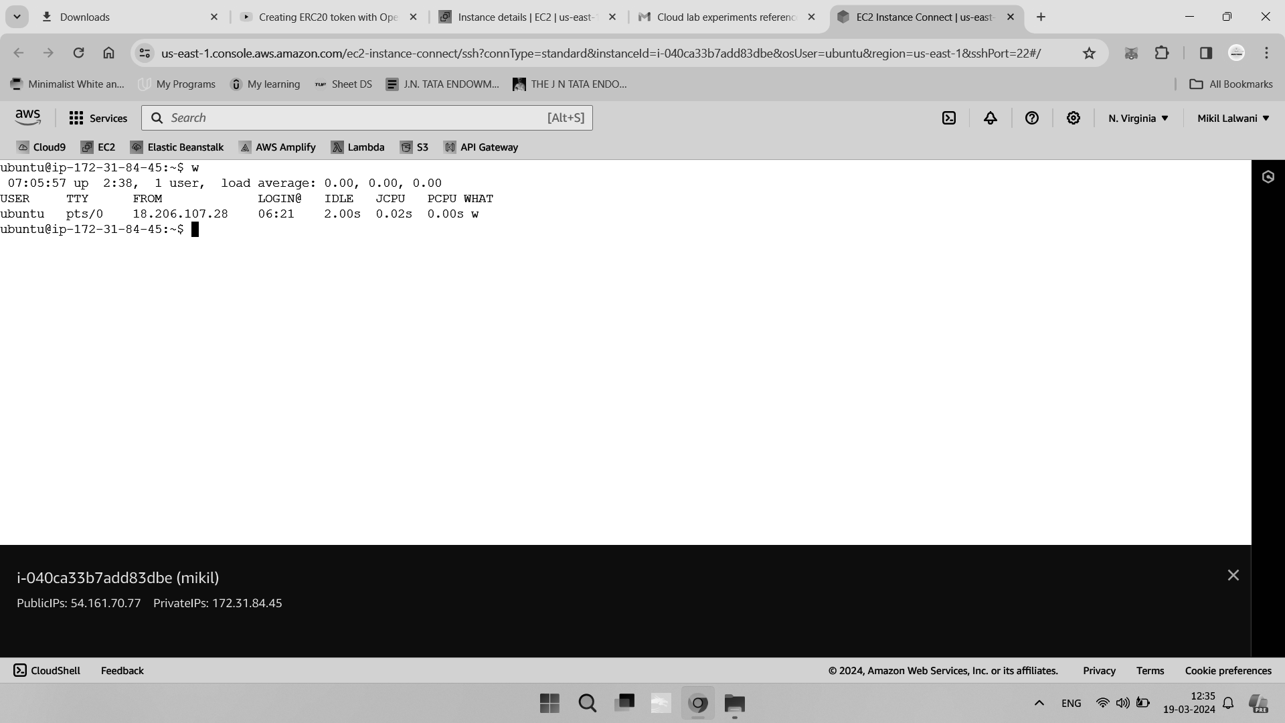

This will output something similar to the following:

Locate your user account in the list and take a note of the connecting IP address. Here we use the example IP of 13.233.177.5

In order to begin implementing your IP address allowlist, open the OpenSSH server

configuration file in nano or your preferred text editor:

sudo nano /etc/ssh/sshd_config

You can implement IP address allowlists using the AllowUsers configuration directive, which restricts user authentications based on username and/or IP address.

Your own system setup and requirements will determine which specific configuration is the most appropriate. The following examples will help you to identify the most suitable one:

Restrict all users to a specific IP address:

AllowUsers *@18.206.107.28

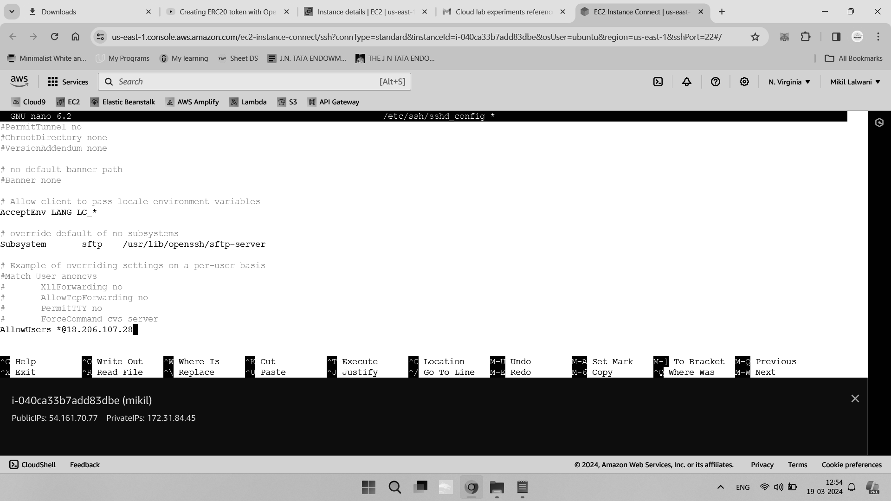

Restrict all users to a specific IP address range using Classless Inter-Domain Routing (CIDR)

notation:

AllowUsers *@18.206.107.28/24

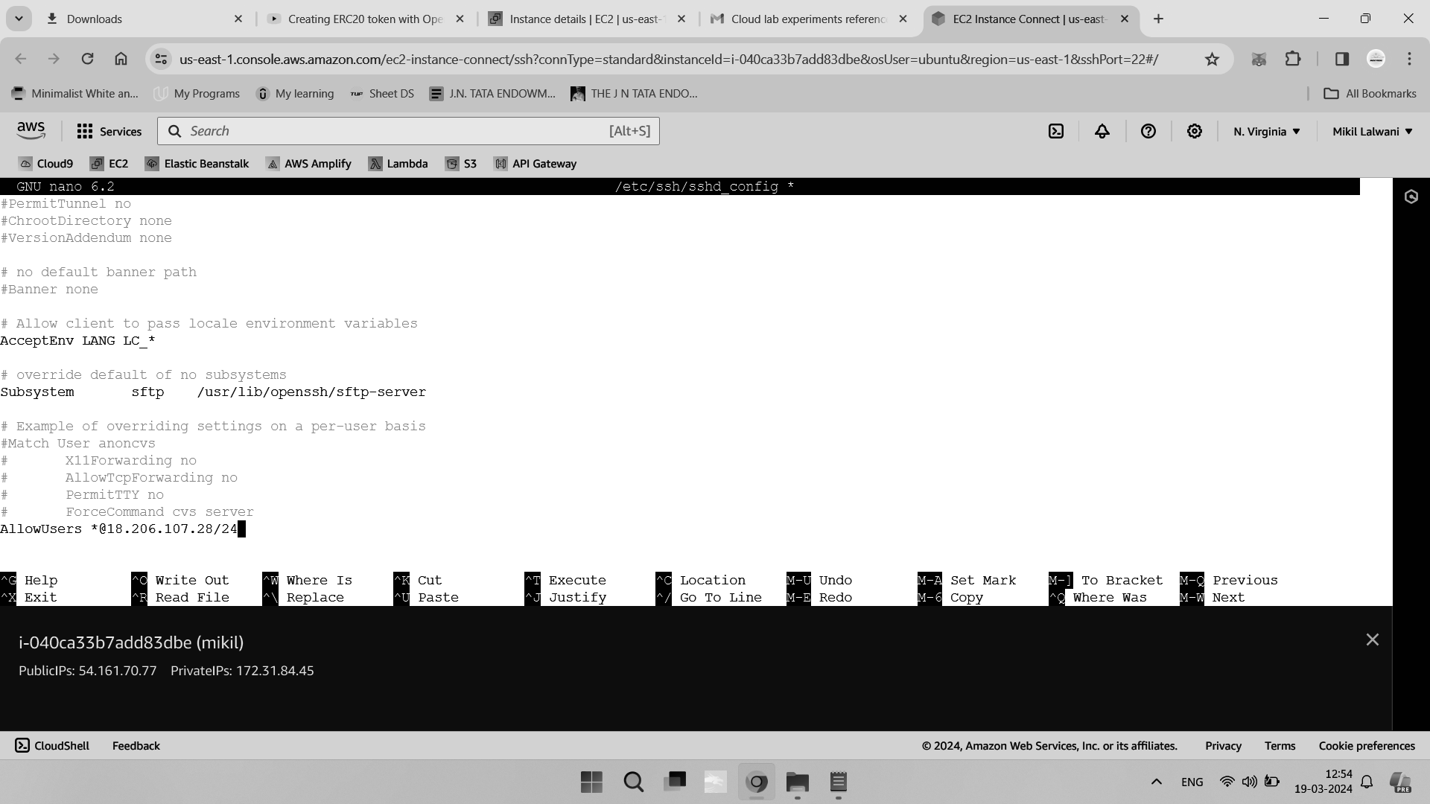

Restrict all users to a specific IP address range (using wildcards):

AllowUsers *@18.206.107.*

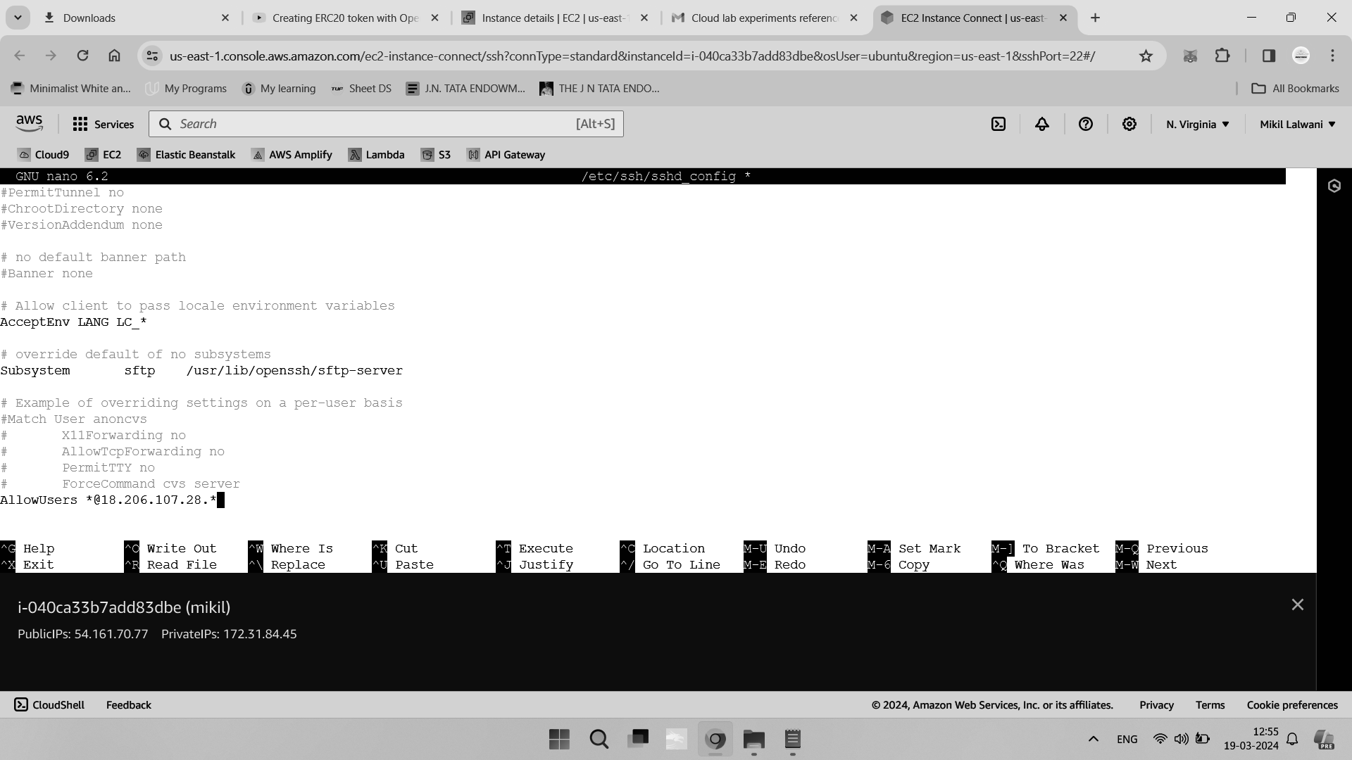

Restrict all users to multiple specific IP addresses and ranges:

AllowUsers *@18.206.107.28 *@18.206.107.29 *@192.0.2.0/24 *@172.16.*.1

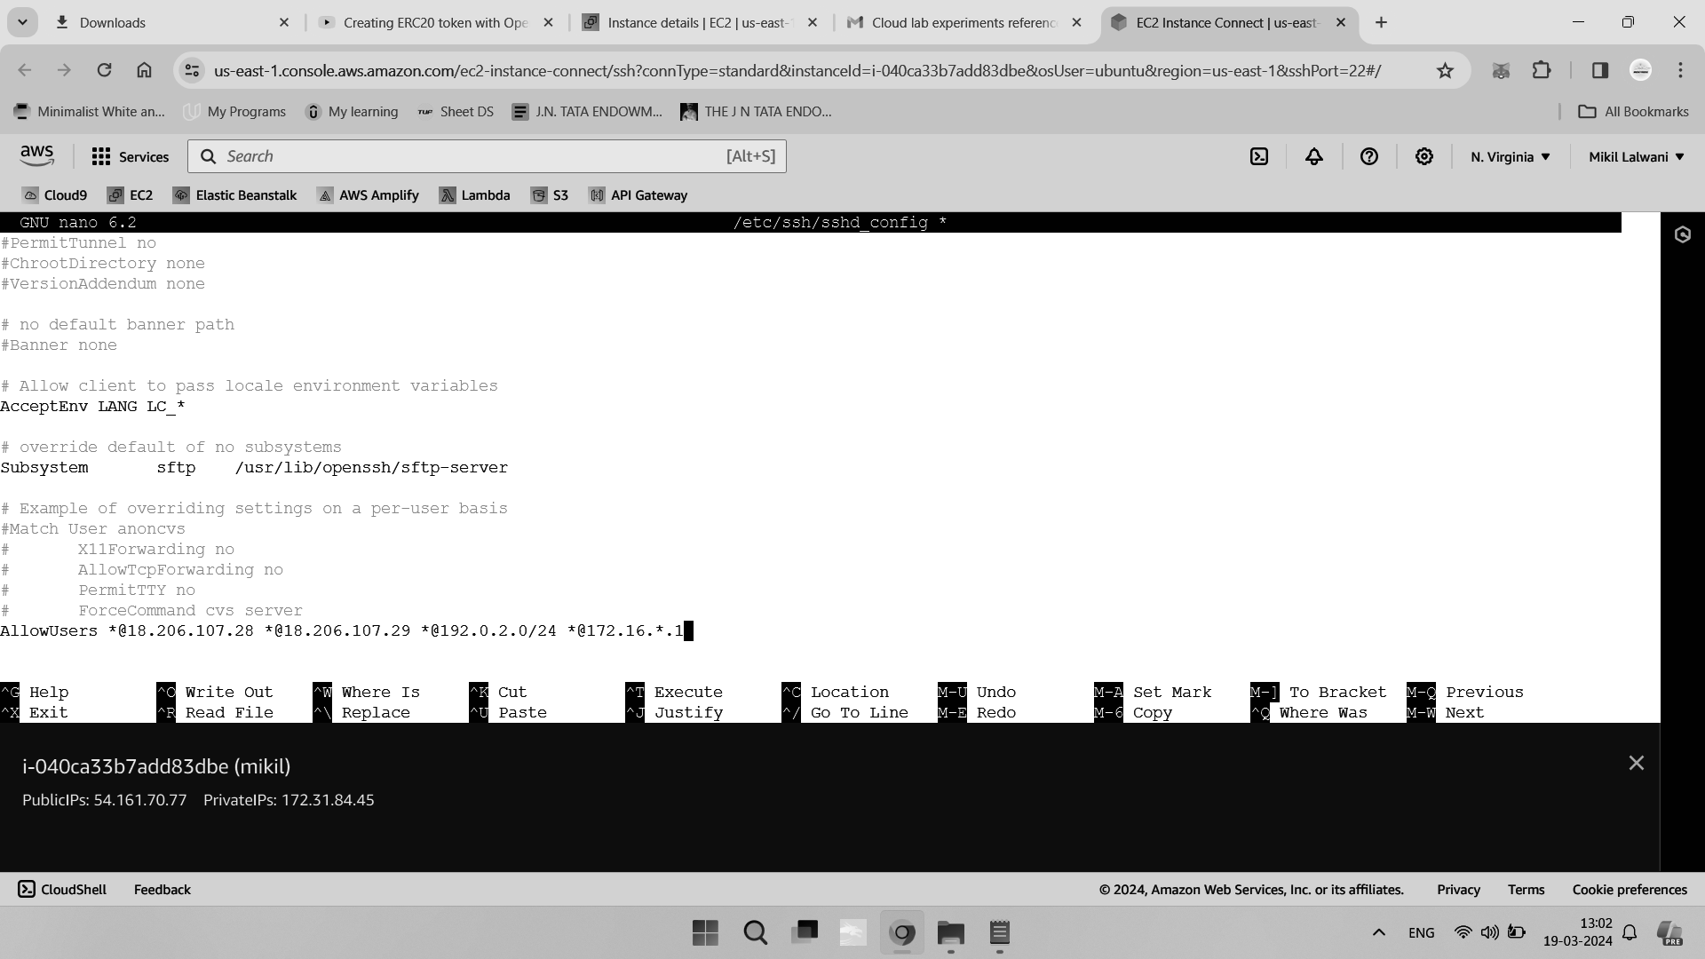

Disallow all users except for named users from specific IP addresses:

AllowUsers sammy@18.206.107.28 alex@18.206.107.29

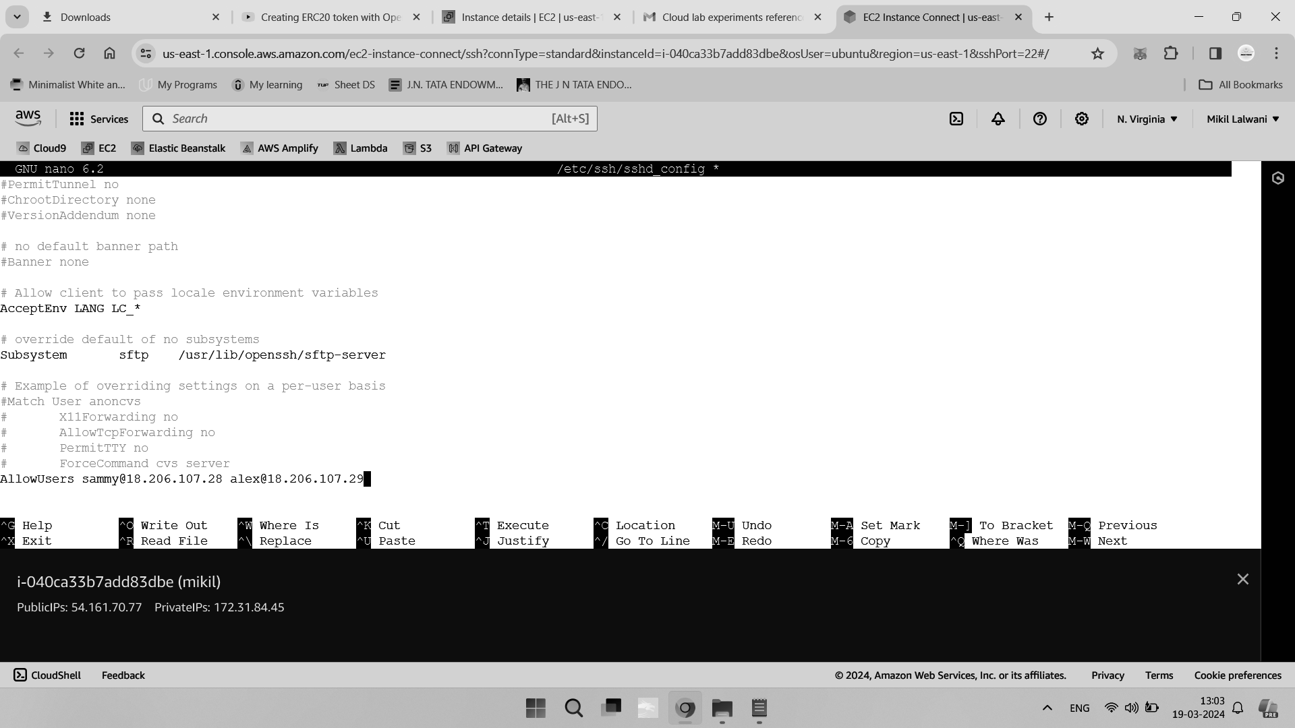

Restrict a specific user to a specific IP address, while continuing to allow all other users to log in without restrictions:

Match User ashley

AllowUsers sammy@18.206.107.28

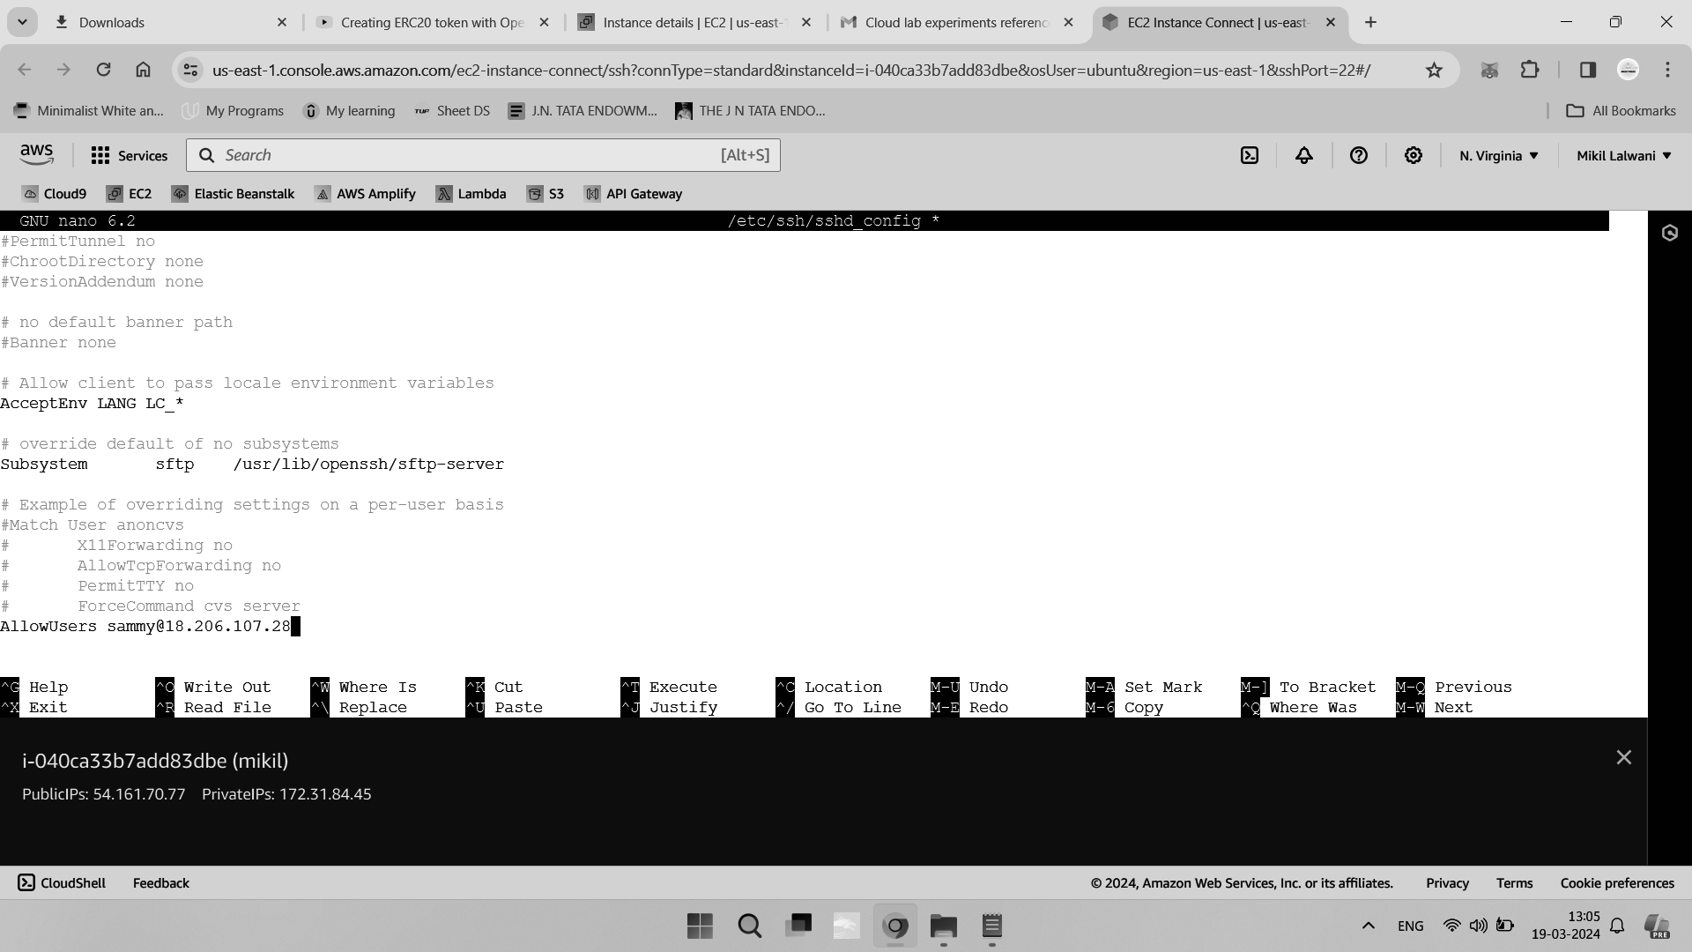

Save and close the file, and then proceed to test your configuration syntax:

sudo sshd -t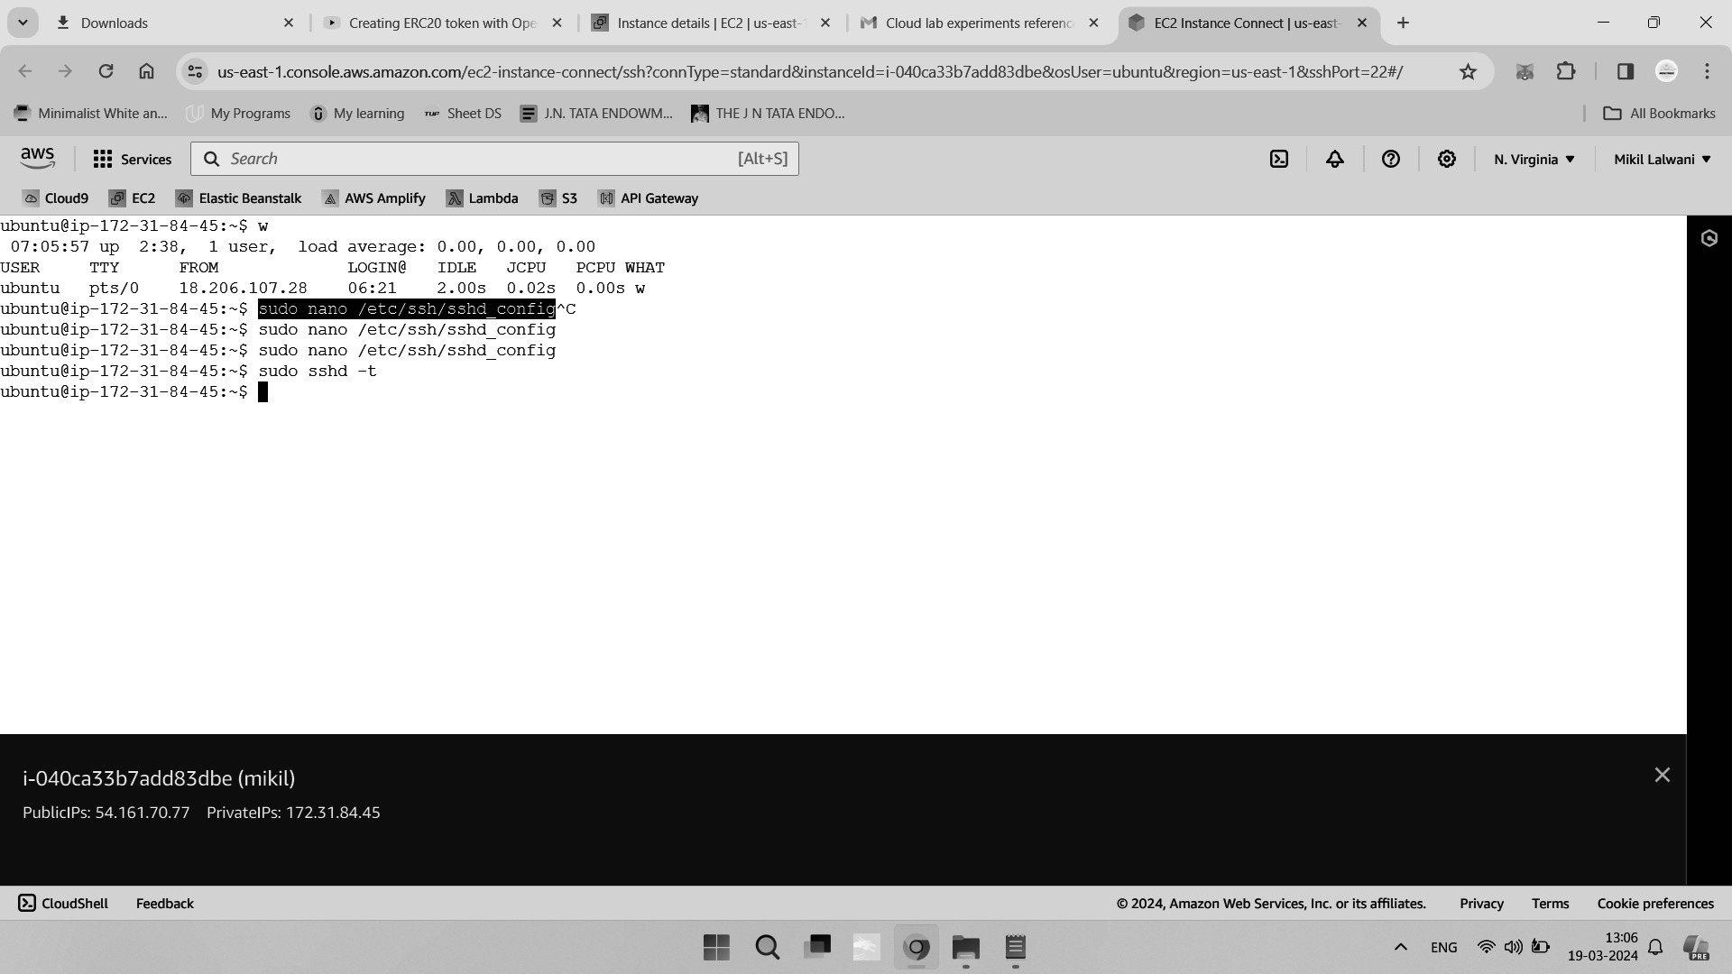

If no errors are reported, you can reload OpenSSH server to apply your configuration:

sudo systemctl reload sshd.service

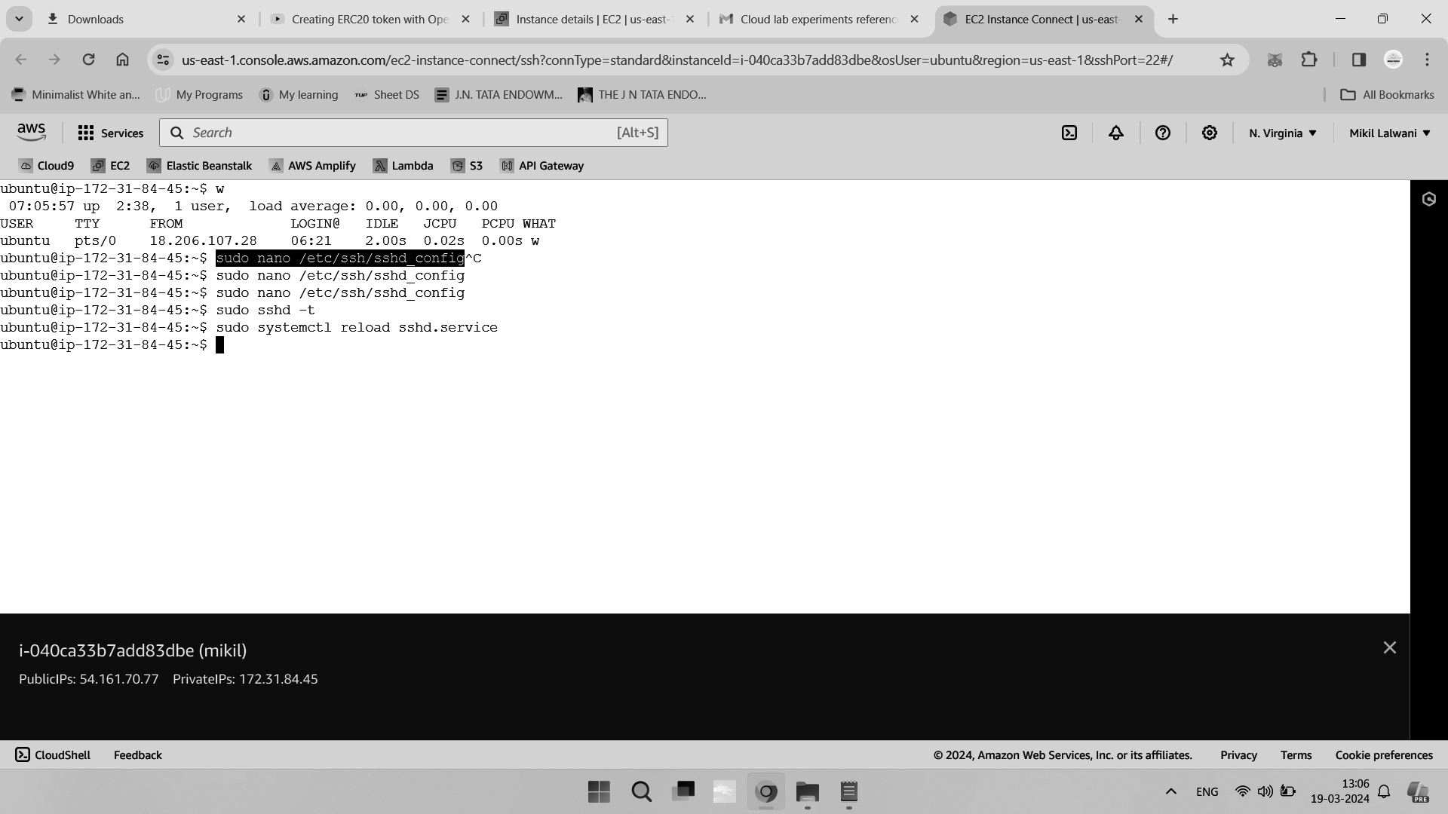

Restricting the Shell of a User

In this step, you’ll explore the various options for restricting the shell of an SSH user.

In addition to providing remote shell access, SSH is also great for transferring files and other data, for example, via SFTP. However, you may not always want to grant full shell access to users when they only need to be able to carry out file transfers.

There are multiple configurations within OpenSSH server that you can use to restrict the shell environment of particular users. For instance, in this tutorial, we will use these to create SFTP-only users.

Firstly, you can use the /usr/sbin/nologin shell to disable interactive logins for certain user accounts, while still allowing non-interactive sessions to function, like file transfers,

tunneling, and so on.

To create a new user with the nologin shell, use the following command:

sudo adduser --shell /usr/sbin/nologin mikil

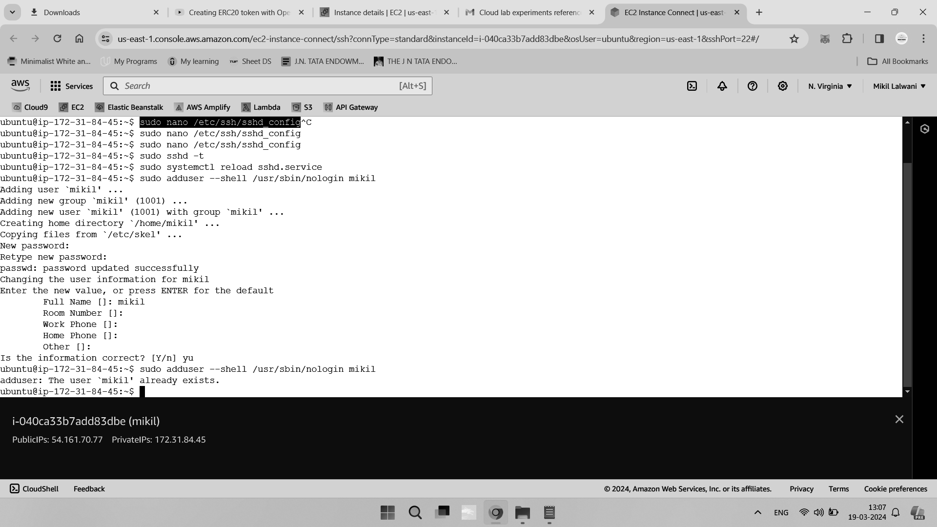

If you then attempt to interactively log in as one of these users, the request will be rejected:

sudo su mikil

This will output something similar to the following message:

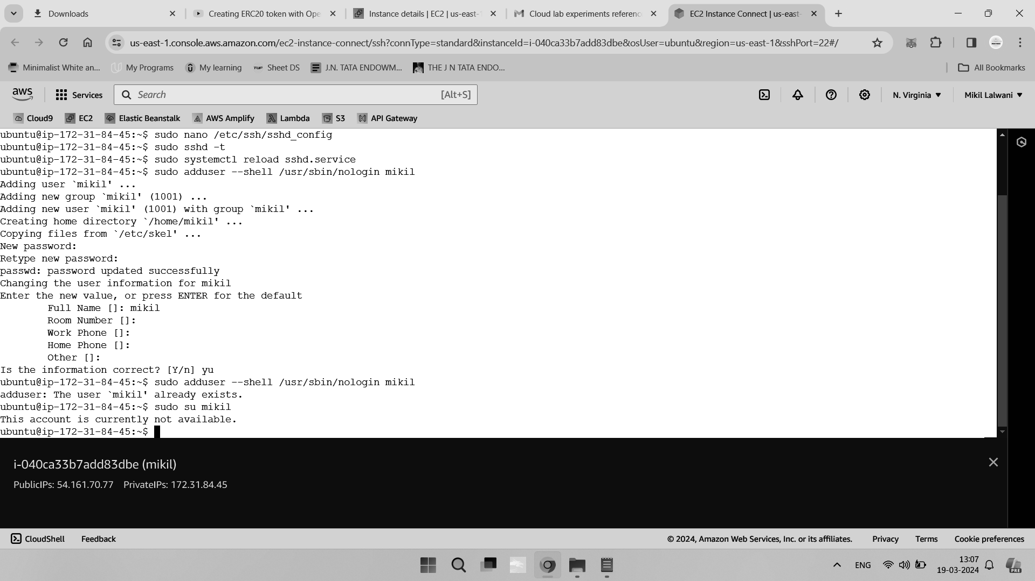

Despite the rejection message on interactive logins, other actions such as file transfers will still be allowed.

Advanced Hardening

In this final step, you will implement various additional hardening measures to make access to your SSH server as secure as possible.

OpenSSH servers can impose restrictions on a per-key basis. Specifically, restrictions can be applied to any public keys that are present in the .ssh/authorized_keys file. This ability is particularly useful to control access for machine-to-machine sessions, as well as providing the ability for non-sudo users to control the restrictions for their own user account.

While you can apply most of these restrictions at the system or user level using the

/etc/ssh/sshd_configuration file, it can be advantageous to implement them at the key-level as well, to provide defense-in-depth and an additional failsafe in the event of accidental system-wide configuration errors.

Begin by opening your .ssh/authorized_keys file in nano or your preferred editor:

nano ~/.ssh/authorized_keys

Once you’ve opened your authorized_keys file, you will see that each line contains an SSH public key, which will most likely begin with something like ssh-rsa AAAB.... Additional configuration options can be added to the beginning of the line, and these will only apply to successful authentications against that specific public key. The following restriction options are available:

● no-agent-forwarding: Disable SSH agent forwarding.

● no-port-forwarding: Disable SSH port forwarding.

● no-pty: Disable the ability to allocate a tty (i.e. start a shell).

● no-user-rc: Prevent execution of the ~/.ssh/rc file.

● no-X11-forwarding: Disable X11 display forwarding.

You can apply these to disable specific SSH features for specific keys. For example, to

disable agent forwarding and X11 forwarding for a key, you would use the following

configuration:

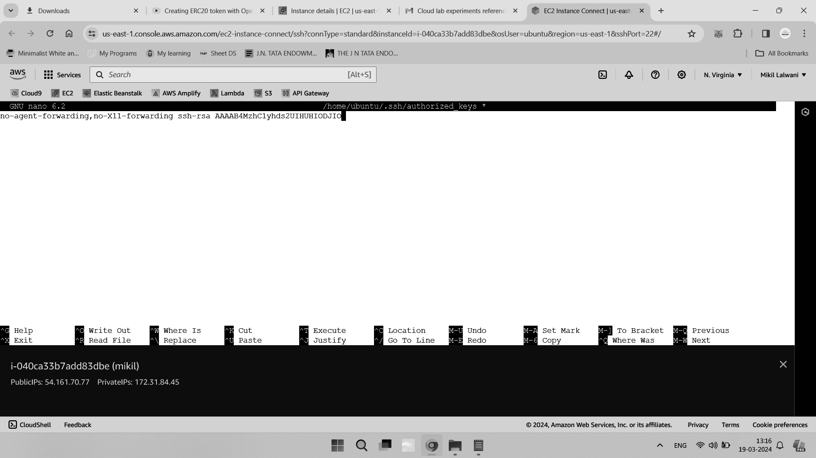

You may also wish to consider using the command option, which is very similar to the

ForceCommand option described in Step 3. This doesn’t provide a direct benefit if you’re already using ForceCommand, but it is good defense-in-depth to have it in place, just in the unlikely event that your main OpenSSH server configuration file is overwritten, edited, and so on. For example, to force users authenticating using a specific key to execute a specific command upon login, you can add the following configuration:

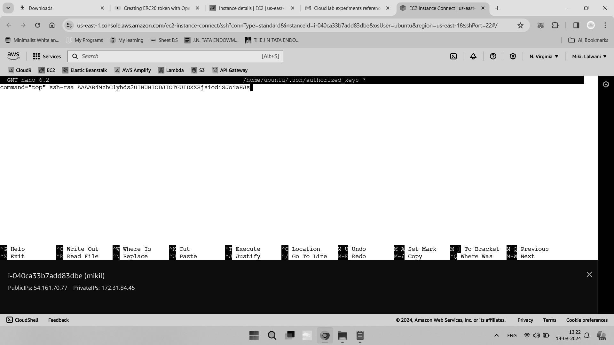

Finally, to best use the per-key restrictions for the SFTP-only user that you created in Step 3, you can use the following configuration:

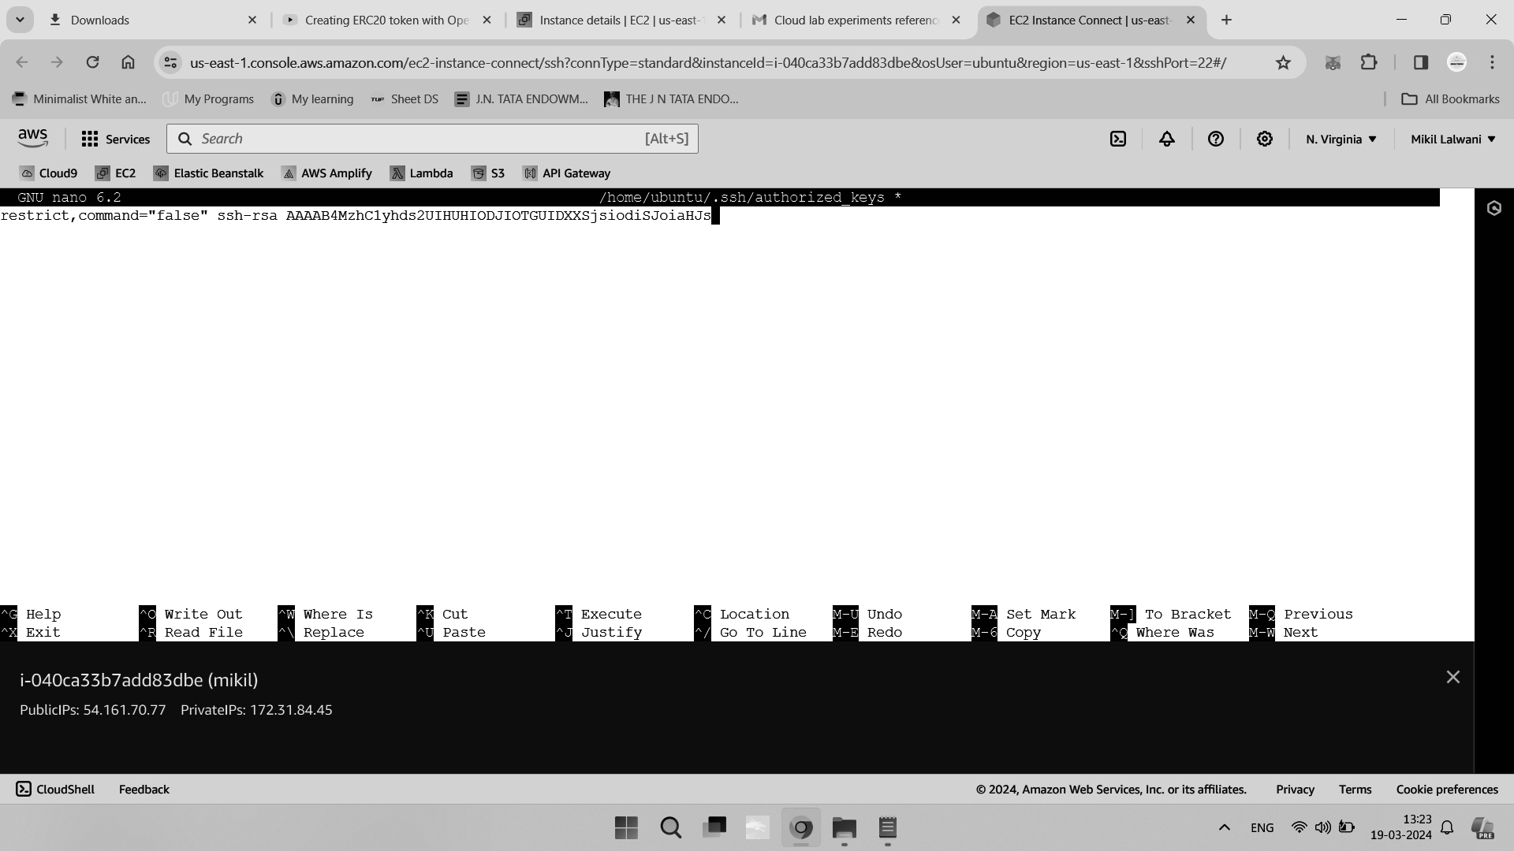

The restrict option will disable all interactive access, and the command=”false” option acts as a second line of defense in the event that the ForceCommand option or nologin shell were to fail.

Save and close the file to apply the configuration. This will take effect immediately for all

new logins, so you don’t need to reload OpenSSH manually.

In conclusion, you reviewed your OpenSSH server configuration and implemented various hardening measures to help secure your server. The options that you configured have reduced the overall attack surface of your server by disabling unused features and locking down the access of specific users.

**Conclusion -**

Thus, we successfully studied and implemented Security as a Service on AWS/Azure.